

Personal Development Planner



“Where sparks of thoughts collide”

2025

Personal Development Planner
“Where sparks of thought collide”

A Personal Development Planner Journal is a record of your reflections and intended actions as a result of undertaking a course of study.
It is not just a diary or record of “What you have done”, but a record of what you have learned and critically reflected upon. It is a personal record of your own learning. As such it is a document which is unique to you and cannot be ‘right’ or ‘wrong’. A personal Development Planner helps you to record, structure, think about, reflect upon, plan, develop and action your learning.

The planner consists of three parts:
1. Critical reflection,
2. Behavioral Change, and
3. Action Planning.

1. Critical Reflection encourages you to consider the following questions:
- What did I learn?
- What did I already know?
- What didn’t I understand?
- What do I want to know more about?
- What actions do I need to take in relation to the 4 questions?

2. Behavioral Change asks you to consider your current practices and make
changes by asking 5 questions:
- What do I need to start doing?
- What do I need to do more of?
- What do I need to do less of?
- What do I need to continue to do?
- What do I need to stop doing?

3. Action Planning provides the opportunity to aggregate the information from the first two steps and decide three or four really important actions you need to take to improve your personal development or organisational effectiveness or both.
- What goals do I need to set?
- What actions do I need to take to achieve the goals?
- Who will be responsible for the actions?
- When do I expect the goals to be achieved?
- What support will the responsible person need to implement the goal?

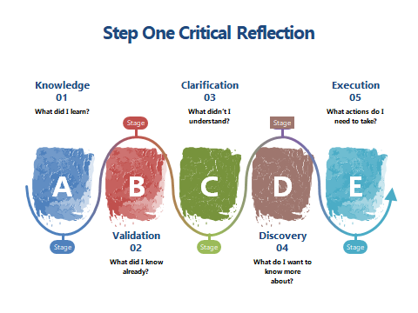
What did I learn?

What did I know already?

What didn’t I understand?

What do I want to know more about?

What actions do I need to take as a result of asking those four questions?

Step 2 Behavioural Change
“ Changing my behaviour to achieve a better result”.

As a result of my reflections and course content I intend to:

Start doing

Do more of

Do less of

Continue doing

Stop doing

Must do

Should do

Could do

Step 3 Action Planning “Turning words into action”

Goal | Actions | Who is responsible | By when | Support needed

